[AWS Cloud Architecture For Java Spring Boot Developers](https://tcsglobal.udemy.com/course/aws-java/)

Design, Deploy, Secure Applications with VPC. Subnets, Auto Scaling, Load Balancing, ECS Fargate, CI/CD Pipelines

**Description**

**Take your Java Spring Boot development skills to the cloud and build robust, scalable applications!**

This comprehensive course equips Java Spring Boot developers with the essential knowledge to design and deploy highly available, scalable, secure, and reliable applications on the AWS cloud platform. **No prior AWS experience is necessary!**

We'll begin with cloud computing fundamentals and progressively guide you through the core AWS services crucial for your success:

* **Compute:** Explore both EC2 instances and ECS Fargate for containerized deployments
* **Storage:** Explore object storage with S3 for efficient data management.
* **Identity & Access Management (IAM):** Implement robust security measures to protect your AWS resources.
* **Databases:** Leverage RDS for managing relational databases effectively.
* **Load Balancing:** Uncover the power of Application Load Balancers (ALB) to ensure high availability for your applications.
* **Content Delivery Network (CDN):** Optimize global content delivery with CloudFront.
* **DNS Services:** Learn to manage domain names effectively using Route 53.
* **Networking:** Gain a comprehensive understanding of VPCs, Subnets, NAT Gateways, and Route Tables to build secure and scalable network architectures.
* **Auto Scaling:** Implement automated scaling mechanisms to dynamically adjust resources based on application demands.

**Embrace modern CI/CD practices!** We'll delve into ***CodeBuild***, ***CodeCommit***, and ***CodePipeline*** to establish automated deployment workflows and ensure smooth rolling updates with zero downtime deployments.

**By the end of this course, you'll be equipped to:**

* Design and deploy highly available, scalable, and secure Cloud Infrastructure on AWS
* Deploy Java / Spring Boot application
* Implement containerization with ECS Fargate for efficient resource utilization
* Leverage CI/CD pipelines for automated application deployments and updates
* AutoScaling
* Manage infrastructure with core AWS services like S3, IAM, RDS, and more.
* Build a strong foundation for your future certification.

## Instructor

[**Vinoth Selvaraj**](https://tcsglobal.udemy.com/user/vinoth-selvaraj/)

Principal Engineer

Vinoth is a **Principal Engineer** with certifications as an **AWS Certified Solutions Architect Associate, Certified Kubernetes Application Developer**, and **Google Cloud Engineer**. He is passionate about software development, with a focus on Microservice Architecture, cloud computing, and developing scalable, high-performance distributed systems.

An avid enthusiast of **Java, Reactive Programming, Spring, Docker, Kubernetes, and Cloud Computing**, Vinoth expertly leverages these technologies to deliver robust and scalable solutions.

Create Security group

**\*\*\* Resource *** - Docker Command For Postgres**

<https://github.com/vinsguru/aws-cloud-architect-essentials/blob/main/ec2/running-postgres.md>

So now we are going to launch 3 EC2 Instances

We have 3 instances are up and running

Logging in to db

Docker command to run postgress

Now DB is ready to accept connections

Not trying connecting to app instance

Not app is trying to connect to db

Sometimes people do like below, but it is of high risk

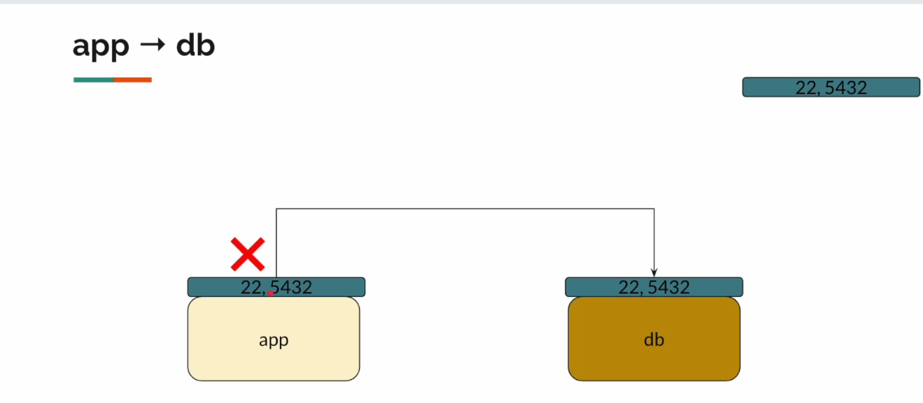

They open 5432 SG for all, but this should be avoided.

Terminated all instances and Removed all Security Groups.

13. Self referencing security groups.

Default SG has 1 default Inbound rule with all traffics allowed.

EC2 instance – User Data

Some commands or Scripts that we want to run once the system loads and gets ready.

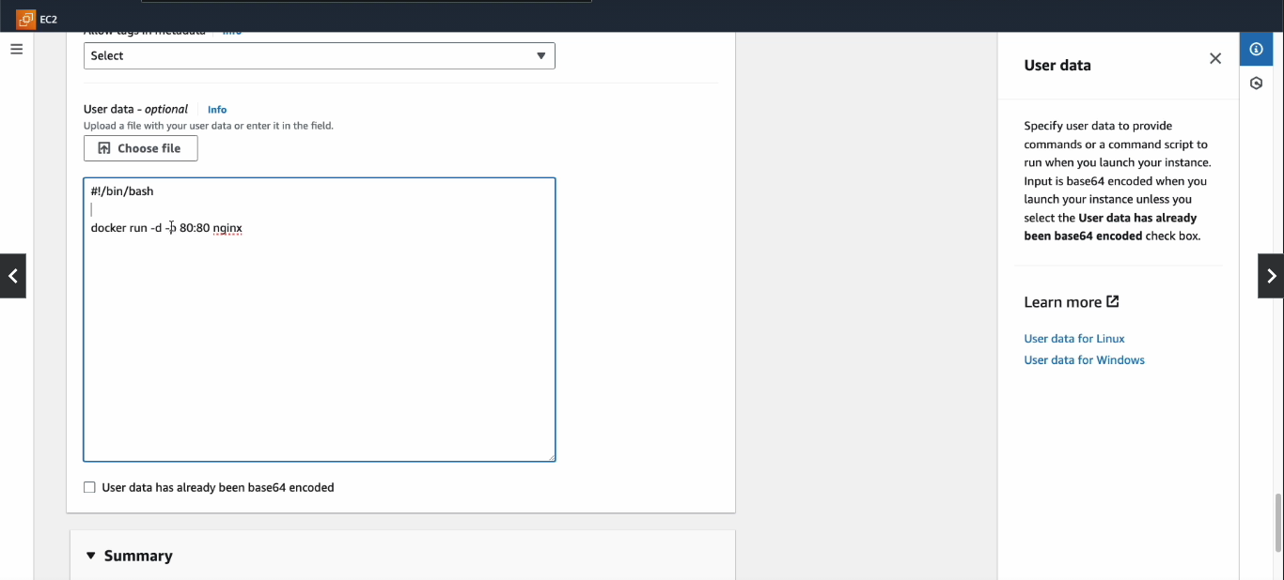

Summary

Region – Geographical location where we will be deploying our application.

In Microservices architecture we can use self referencing SGs.